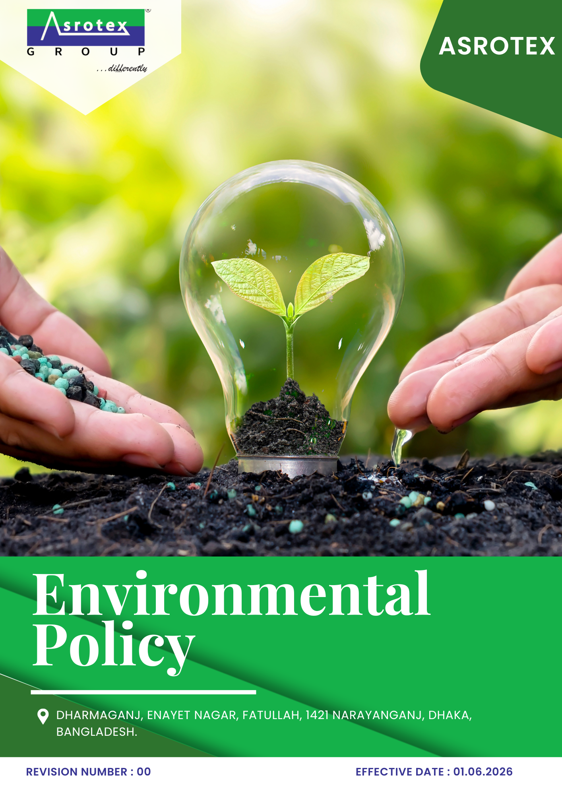

TABLE OF CONTENTS

01 Preface 3
02 Purpose 3
03 Scope 3
04 Environmental Commitments 3
05 Roles & Responsibilities 4
06 Action Areas 4
07 Environmental Performance, Monitoring & Reporting 9
08 Review Mechanism & Continual Improvement 9
Annexure A – United Nations Sustainable Development Goals (UNSDGs) 10
Employee Acknowledgment Form 11

01 Preface
Asrotex is committed to conducting its operations in an environmentally responsible and sustainable manner. We recognize our responsibility to minimize environmental impacts by promoting efficient resource utilization, pollution prevention, climate action, and continual improvement across all business activities.
This Environmental Policy provides the framework for integrating environmental considerations into our operations, supporting compliance with applicable legal requirements, customer expectations, and internationally recognized standards. Through innovation, employee engagement, and responsible business practices, Asrotex strives to enhance environmental performance and contribute to sustainable development while creating long-term value for all stakeholders.

02 Purpose
The purpose of this Environmental Policy is to establish a framework for managing Asrotex's environmental responsibilities. It aims to promote regulatory compliance, pollution prevention, efficient resource utilization, and continual improvement in environmental performance across all operations.

03 Scope
This Environmental Policy applies to all operations and activities of Asrotex located below
Sr. No. | Site | Address
1 | Asrotex | Dharmaganj, Enayet Nagar, Fatullah, 1421 Narayanganj, Dhaka, Bangladesh.

The policy covers all manufacturing, warehouse, utility, maintenance, laboratory, and administrative functions under the Company's operational control. It is applicable to all employees, contract workers, contractors, suppliers, service providers, and other relevant stakeholders engaged in activities on behalf of Asrotex.

04 Environmental Commitments
Asrotex Ltd. is committed to:
- Integrating environmental sustainability into strategic planning and business operations.
- Encouraging innovation and adopting environmentally responsible technologies and practices.
- Strengthening environmental risk management and business resilience.
- Collaborating with employees, suppliers, customers, and other stakeholders to promote sustainable practices.
- Monitoring environmental performance and using data-driven decisions to improve operational efficiency.
- Driving continual improvement to support long-term sustainable business growth.
The Company has established 2023 as the baseline year for measuring environmental performance and tracking progress against its environmental objectives and targets.

05 Roles & Responsibilities
The successful implementation of this Environmental Policy requires the commitment and active participation of all personnel at Asrotex. Responsibilities are assigned as follows :
Managing Director
- Provide leadership and strategic direction for environmental management.
- Ensure adequate resources are available to achieve the Company's environmental objectives and commitments.
Department Heads
- Implement this policy within their respective departments.
- Ensure compliance with applicable environmental procedures and support the achievement of environmental objectives and targets.
Employees
- Comply with the requirements of this policy and established environmental procedures.
- Use resources responsibly and report environmental concerns or improvement opportunities.
Contractors, Suppliers & Business Partners
- Conduct activities in accordance with Asrotex's environmental requirements.
- Support the Company's environmental commitments and applicable sustainability requirements while performing work on behalf of Asrotex.

06 Action Areas
1 Energy Consumption and Greenhouse Gases (GHG)
Objective
- To improve energy efficiency, reduce greenhouse gas (GHG) emissions, and promote the use of cleaner energy sources across Asrotex's operations.
Initiatives
- Improve energy efficiency across knitting, garment manufacturing, warehouse, and administrative operations.
- Optimize the performance of production equipment, lighting, and utility systems through regular monitoring and maintenance.
- Promote the adoption of energy-efficient technologies and renewable energy solutions, where technically and economically feasible.
- Monitor energy consumption and greenhouse gas (GHG) emissions to support data-driven decision-making and continual improvement.
TARGET
Reduce Scope 1 and Scope 2 GHG emissions intensity by 40% by year 2030.
Increase the share of renewable energy to 30% of total electricity consumption by year 2030.
Reduce total Energy Consumption by 5% till year 2030.
2 Water Management
Objective
- To optimize water consumption, enhance water efficiency, and ensure responsible management of wastewater across Asrotex's operations.
Initiatives
- Optimize water use across production, utility, and support operations through efficient water management practices.
- Monitor water consumption and identify opportunities to improve water efficiency.
- Promote water conservation through operational controls, preventive maintenance, and employee awareness.
- Ensure wastewater is managed and discharged in accordance with applicable environmental requirements.
TARGET
Reduce freshwater consumption intensity by 25% by year 2030.
Reuse or recycle 30% of treated wastewater by year 2030.
3 Sustainable Materials, Chemicals, and Waste Management
Objective
To promote the responsible use of materials and chemicals while minimizing waste generation through sustainable resource management and circular economy practices.
Initiatives
- Promote the responsible procurement and efficient use of sustainable materials across manufacturing operations.
- Ensure the safe handling, storage, use, and disposal of chemicals in accordance with applicable requirements and industry best practices.
- Minimize waste generation by adopting waste reduction, reuse, recycling, and resource recovery practices.
- Strengthen waste segregation and ensure environmentally responsible disposal of hazardous and non-hazardous waste through authorized service providers.

TARGET
Increase the use of sustainable or certified raw materials to at least 50% of total material consumption by year 2030.
Reduce waste sent to landfill by 30% by year 2030 through waste reduction, reuse, and recycling initiatives.
Increase the recycling or recovery of non-hazardous waste to 80% by year 2030.
4 Biodiversity & Natural Resource Conservation
Objective
To protect biodiversity and conserve natural resources by minimizing the environmental impacts of Asrotex's operations.
Initiatives
- Protect and maintain green areas within and around the Company's operational premises.
- Consider biodiversity aspects in operational planning and expansion activities, where applicable.
- Encourage tree plantation and environmental conservation initiatives in collaboration with employees and local communities.
TARGET
Plant and maintain 1,000 trees and green plantation till year 2030.
Maintain 100% compliance with biodiversity and land-use requirements applicable to the Company's operations by year 2030.
Implement two biodiversity conservation or green campus initiatives by year 2030.

5 Air Pollution and Emission Control
Objective
To minimize air emissions and improve air quality by implementing effective emission control measures and cleaner operational practices.
Initiatives
- Monitor and control air emissions from manufacturing and utility operations.
- Maintain emission control equipment to ensure effective performance and regulatory compliance.
- Promote cleaner production practices and energy-efficient technologies to reduce air pollutants.
- Periodically assess emission performance and identify opportunities for continual improvement.

TARGET
Reduce particulate matter (PM) emissions by 20% by year 2030.
Reduce air emission intensity by 25% by year 2030 through process improvements and cleaner technologies.
6 Product Use
Objective
To promote the responsible use of products by enhancing product quality, safety, durability, and environmental performance throughout their intended lifecycle.
Initiatives
- Design and manufacture products that meet applicable quality, environmental, and customer requirements.
- Promote the efficient use of sustainable and responsibly sourced materials in product development.
- Continuously improve product durability, functionality, and resource efficiency.
- Consider environmental impacts during product design and manufacturing processes.
TARGET
Increase the use of sustainable or certified raw materials in products to at 50% by year 2030.
Ensure 100% of applicable products comply with customer and regulatory environmental requirements by year 2030.
Maintain a customer complaint rate related to product quality and safety below 1% annually.
Reduce product use defects by 99% by year 2030.
7 Customer Health and Safety
Objective
To ensure that products manufactured by Asrotex are safe for customers and comply with applicable quality, environmental, and product safety requirements.
Initiatives
- Ensure products comply with applicable customer, regulatory, and product safety requirements.
- Conduct product quality and safety testing before shipment, where applicable.
- Continuously improve product safety and quality through monitoring and customer feedback.
TARGET
Achieve 100% compliance with applicable customer product safety and regulatory requirements annually.
Maintain zero product recalls related to health and safety issues each year till 2030 and thereafter.
Maintain a customer complaint rate related to product health and safety below 1% annually.

8 Product End-of-Life treatment
Objective
To support responsible end-of-life management of products by promoting circular economy principles, resource recovery, and environmentally responsible disposal practices.
Initiatives
- Encourage the use of recyclable and environmentally preferred materials in product development.
- Promote product designs that support reuse, recycling, and resource recovery, where feasible.
- Collaborate with customers, suppliers, and other stakeholders to encourage responsible end-of-life management practices.
- Continuously improve product lifecycle performance by considering end-of-life impacts during product development.
TARGET
Support the reuse, recycling, or recovery of 20% of end-of-life products by year 2030 through buy-back programs.
Increase the proportion of recyclable or reusable materials in applicable products to 50% by year 2030.
Implement one product circularity or end-of-life improvement initiatives by year 2030.
9 Environmental Services and Advocacy
Objective
To promote environmental stewardship by encouraging awareness, collaboration, and participation in sustainability initiatives among employees, suppliers, customers, and local communities.
Initiatives
- Promote environmental awareness through training, communication, and engagement programmes.
- Encourage suppliers, customers, and business partners to adopt environmentally responsible practices.
- Support environmental conservation and community initiatives that contribute to sustainable development.
TARGET
Conduct two environmental awareness or community engagement initiatives by year 2030.
Engage 80% of suppliers and business partners in environmental sustainability initiatives by 2030.
Provide environmental awareness training to 100% of employees annually

07 Environmental Performance, Monitoring & Reporting
Asrotex is committed to regularly monitoring and evaluating its environmental performance to ensure the effective implementation of this policy and the achievement of its environmental objectives and targets.
The Company shall:
- Monitor key environmental performance indicators, including energy, water, emissions, waste, and resource consumption.
- Maintain accurate environmental records and periodically review performance against established objectives and targets.
- Conduct internal assessments to identify improvement opportunities and implement corrective actions where required.
- Report environmental performance to management and relevant stakeholders, where applicable, to support transparency and continual improvement.

08 Review Mechanism & Continual Improvement
This Environmental Policy shall be reviewed once after every two years, or earlier if required due to changes in legal requirements, business operations, customer expectations, or other relevant factors.
Asrotex shall periodically evaluate the effectiveness of this policy, review progress against environmental objectives and targets, and implement necessary improvements to enhance environmental performance. The outcomes of reviews shall be considered in updating the policy and supporting the Company's commitment to continual improvement.
Rev. No.  00 | Effective Date  01.06.2026 | Next Review Date  01.06.2028
Approved By:

Annexure A – United Nations Sustainable Development Goals (UNSDGs)
Asrotex recognizes the importance of integrating globally accepted sustainability principles into its environmental management approach. The environmental commitments, objectives, and initiatives outlined in this policy contribute to the following United Nations Sustainable Development Goals (UN SDGs).:
UN SDG | Key Focus Area | Relevant Policy Sections
SDG 6 – Clean Water and Sanitation | Water conservation, efficient water use, and responsible wastewater management | Water Management
SDG 7 – Affordable and Clean Energy | Energy efficiency, renewable energy, and greenhouse gas reduction | Energy Consumption & GHG Management
SDG 9 – Industry, Innovation and Infrastructure | Sustainable manufacturing, innovation, and operational efficiency | Environmental Commitments; Energy Consumption & GHG Management
SDG 12 – Responsible Consumption and Production | Sustainable materials, chemical management, waste minimization, circular economy, product use, and end-of-life management | Sustainable Materials, Chemicals & Waste Management; Product Use; Product End-of-Life Treatment
SDG 13 – Climate Action | Climate change mitigation, emission reduction, and environmental resilience | Energy Consumption & GHG Management; Air Emissions Management
SDG 15 – Life on Land | Biodiversity conservation and responsible natural resource management | Biodiversity & Natural Resource Conservation
SDG 17 – Partnerships for the Goals | Stakeholder collaboration and environmental awareness | Environmental Services & Advocacy; Roles & Responsibilities

Employee Acknowledgment Form
I acknowledge that I have received, read, and understood the Environmental Policy of Asrotex. I understand my responsibilities under this policy and agree to comply with its requirements while performing my duties.
I am committed to supporting the Company's environmental objectives by adopting environmentally responsible practices, conserving resources, preventing pollution, and contributing to the continual improvement of environmental performance.
Name:
Position:
Signature:
Date:

